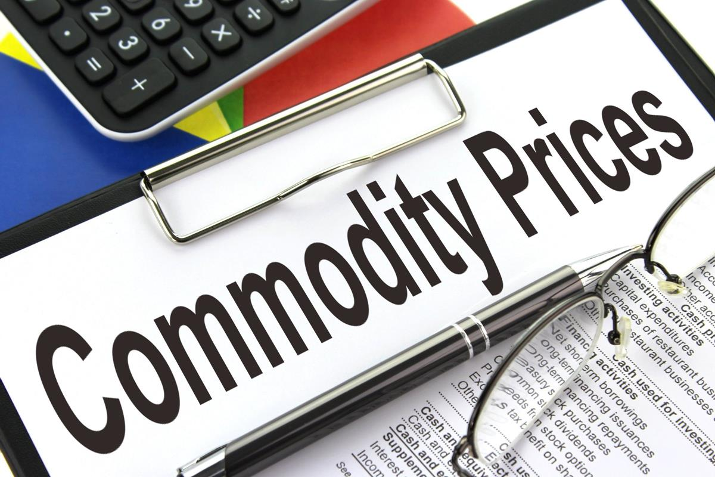

To get Local Commodity Price…click here

2

[This Photo](https://www.picserver.org/photo/8013/Commodity-prices.html) by Unknown Author is licensed under [CC BY-SA](https://creativecommons.org/licenses/by-sa/3.0/)